**Student Name :** G.Rithishkumar

**Register Number :** 732323106041

**Institution :** Ssm College Of Engineering

**Department :** Electronics And Communication Engineering

**Date of Submission :** 29.4.2025

**Github Repository Link :** [**Revolutionizing-customer-support-with-an-intelligent-chatbot-for-automed-assistance/ at main · rithishkumar07/Revolutionizing-customer-support-with-an-intelligent-chatbot-for-automed-assistance**](https://github.com/rithishkumar07/Revolutionizing-customer-support-with-an-intelligent-chatbot-for-automed-assistance/tree/main)

### **1. Problem Statement**

### Customer service is a cornerstone of user satisfaction, yet traditional support systems often struggle with slow response times and inconsistent service quality. This project addresses the need for a more scalable and intelligent solution through the development of a chatbot capable of providing automated, real-time support.

* The core problem is to design a chatbot that not only understands user queries but responds accurately and naturally using AI-driven conversational models. The chatbot will be trained to resolve customer issues, route complex queries to human agents, and continuously improve via feedback.

### **2. Project Objectives**

* Build an intelligent chatbot using NLP and machine learning techniques.
* Enable real-time, automated assistance for frequently asked customer queries.
* Improve response time and reduce manual workload on support staff.
* Train the bot to identify intent, extract relevant entities, and generate appropriate responses.
* Integrate the chatbot with web or mobile platforms via a user-friendly interface.
* Continuously update and improve the chatbot's knowledge b.

### **3. Flowchart of the Project Workflow**

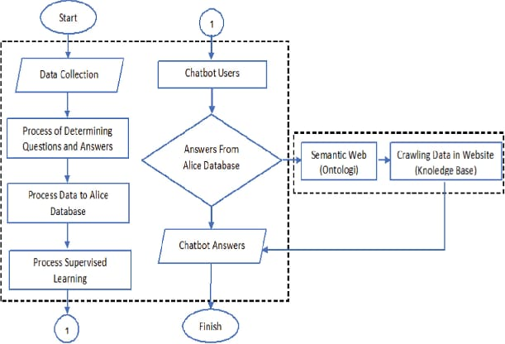

### **4. Data Description**

* - Source of Data: Chat logs, FAQs, and customer support tickets.
* Type of Data: Textual (structured and unstructured).
* Static or Dynamic: Initially static, evolving to dynamic as real-time queries are collected.
* Key Attributes: User query, intent, response, context, timestamp, feedback

### **5. Data Preprocessing**

* Text cleaning: removed punctuation, stop words, and lowercased all text.
* Tokenization and lemmatization.
* Intent labeling for supervised training.
* Vectorization using TF-IDF or word embeddings.
* Train-test split for supervised learning.
* Data set-<https://www.kaggle.com/datasets/blastchar/telco-customer-churn>

### **6. Exploratory Data Analysis (EDA)**

* Frequency analysis of customer queries.
* Analysis of most common intents and response categories.
* Visualization of word clouds and intent distributions.

### **7. Feature Engineering**

* Created features such as query length, keyword density, and session duration.
* Encoded intents as categorical labels.
* Incorporated contextual cues for multi-turn conversations.
* Integrated feedback loop for continuous learning.

### **8. Model Building**

* Algorithms Used: Rule-based fallback system.
* Intent classification using Logistic Regression or BERT.
* Response generation using seq2seq models or retrieval-based approach.
* Model Selection Rationale: - Classifiers for intent detection.
* Retrieval or generative models for flexible responses.
* Evaluation Metrics: - Accuracy, Precision, Recall (for intent classification).
* BLEU Score, Perplexity (for response generation).
* User satisfaction rating.

### **9. Visualization of Results & Model Insights**

### Confusion matrix for intent classification.

### Word embeddings visualization for semantic understanding.

### Feedback and error analysis charts.

### Dashboard showing chatbot usage trends and satisfaction levels

### **10. Tools and Technologies Used**

* Programming Language: Python 3.
* Libraries/Frameworks: NLTK, spaCy, scikit-learn, TensorFlow/PyTorch, Rasa/Dialogflow.
* Deployment: Flask/Streamlit/Gradio.
* Others: GitHub, Colab, Postman.

### **11. Team Members and Contributions**

B.Sanjeev - Responsibilities : Oversaw data collection, led model building, integrated the chatbot system, and managed final deployment.

G.Rithish kumar - Responsibilities: Handled dataset acquisition, data cleaning, and preprocessing, including tokenization and lemmatization.

M.Samuvel - Responsibilities: Focused on model selection and training using BERT/LSTM, performed intent recognition, and fine-tuned response generation.

S.Santhiya - Responsibilities: Developed the web interface using Streamlit or Flask, created the analytics dashboard, and implemented user feedback capture mechanisms.